Student Name – Ujjawal Shrestha

Course – Developing Modern Web Platforms

**Documentation of the course**

The webpage consist total of 6 pages named as: index.html, skills.html, projects.html, gallery.html, contact.html and somemore.html.

The header and navigation bar is same in all the 6 pages. Index page is called home page which contains introduction about me. Below is the screenshot of my index/home page.

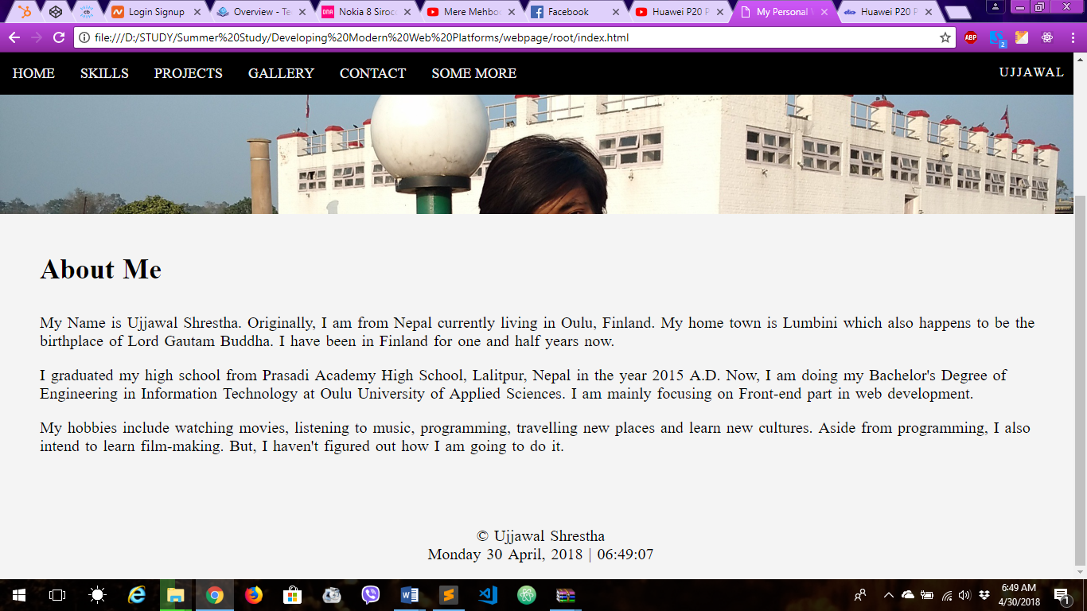

Header is designed in such a way that it is fixed at the top all the time. The external CSS file, which is inside styles folder under the name main.css, is used for styling of the page shown as below in the screenshot.

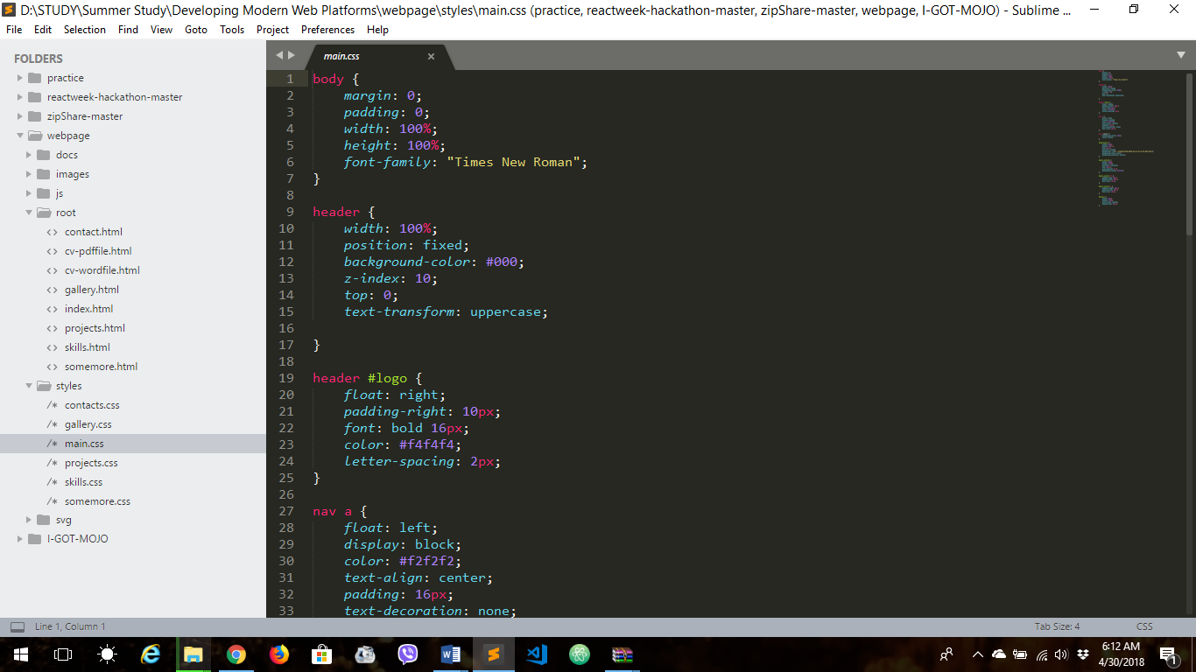

And current date and time is shown in footer section of every page, which was created using JavaScript and is linked at the bottom but inside the body tag of the page. The file is located in js folder and saved as scripts.js.

After the index page, there is skills page, can be reached from home page, which contains technical and basic skills I have as a skill bar and there’s also input field to add new skills that I gain. The skills html coding is shown in below screenshot

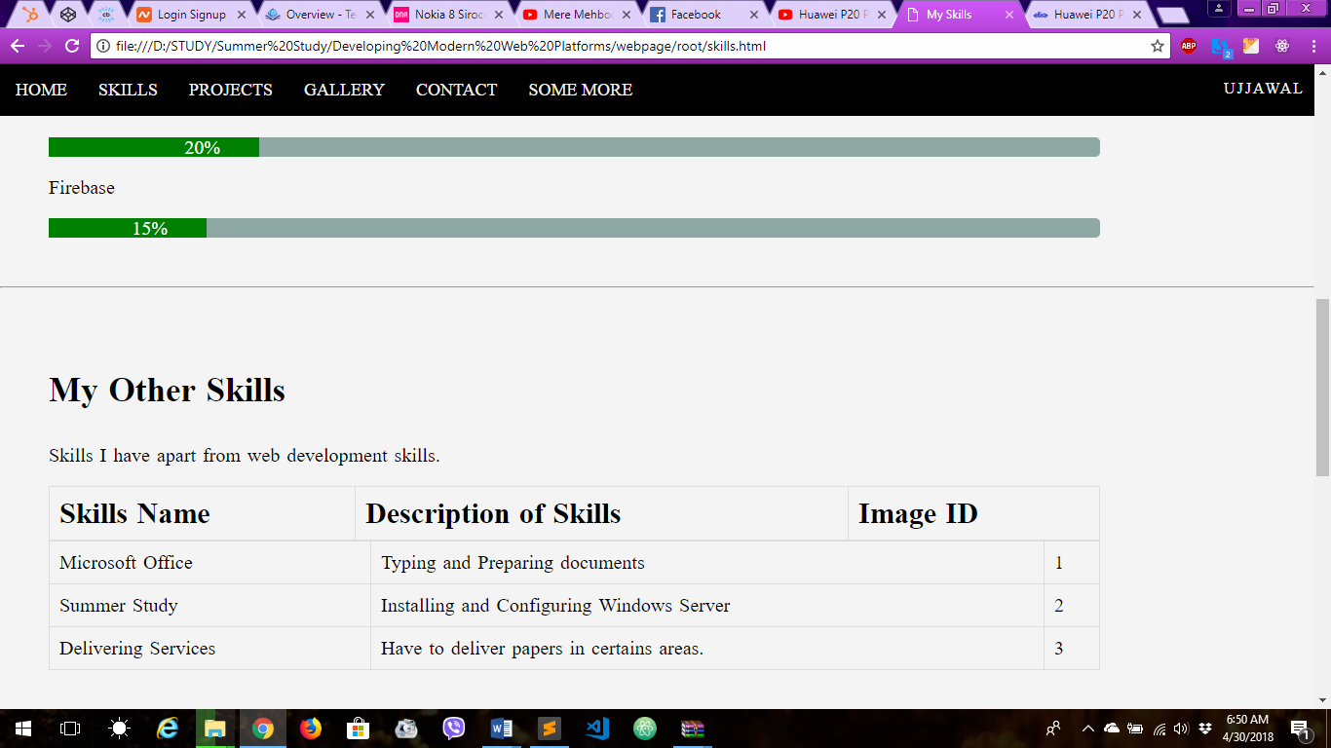

The styling is again done in external CSS file named as skills.css as shown below in screenshots.

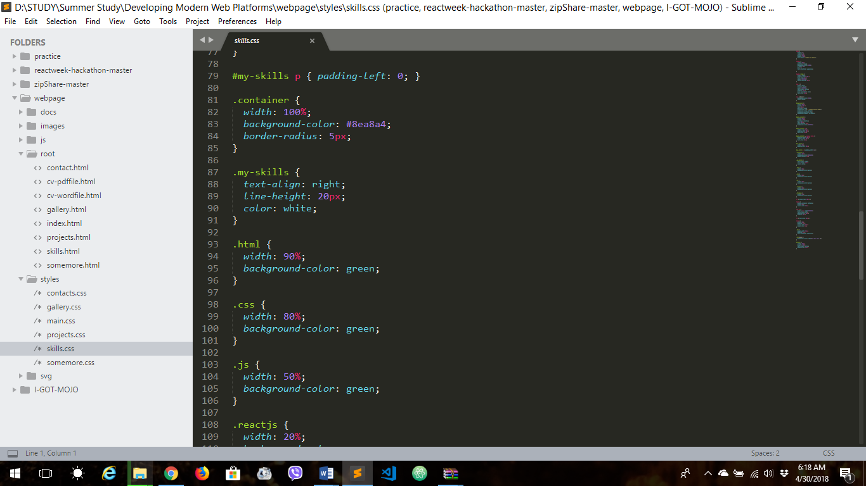

External JavaScript file, named as skills.js and located in js folder, is also linked at the bottom of the html page which contains a function to add and reset the form where skills are added.

Then comes the projects page, which contains the list of 3 projects that I have done individually or in group. Parallax style is being used in this page. Below is the screenshot of the page.

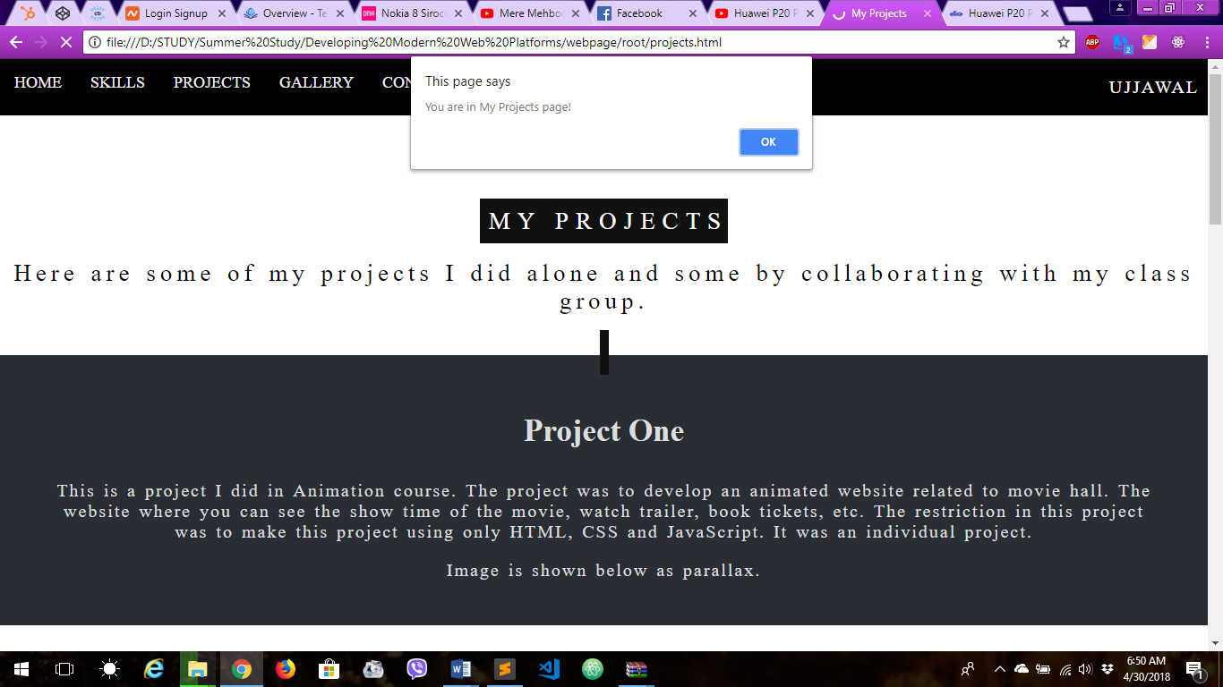

As usual external CSS file was used for styling named as projects.css. Below is the screenshot for the CSS of projects page.

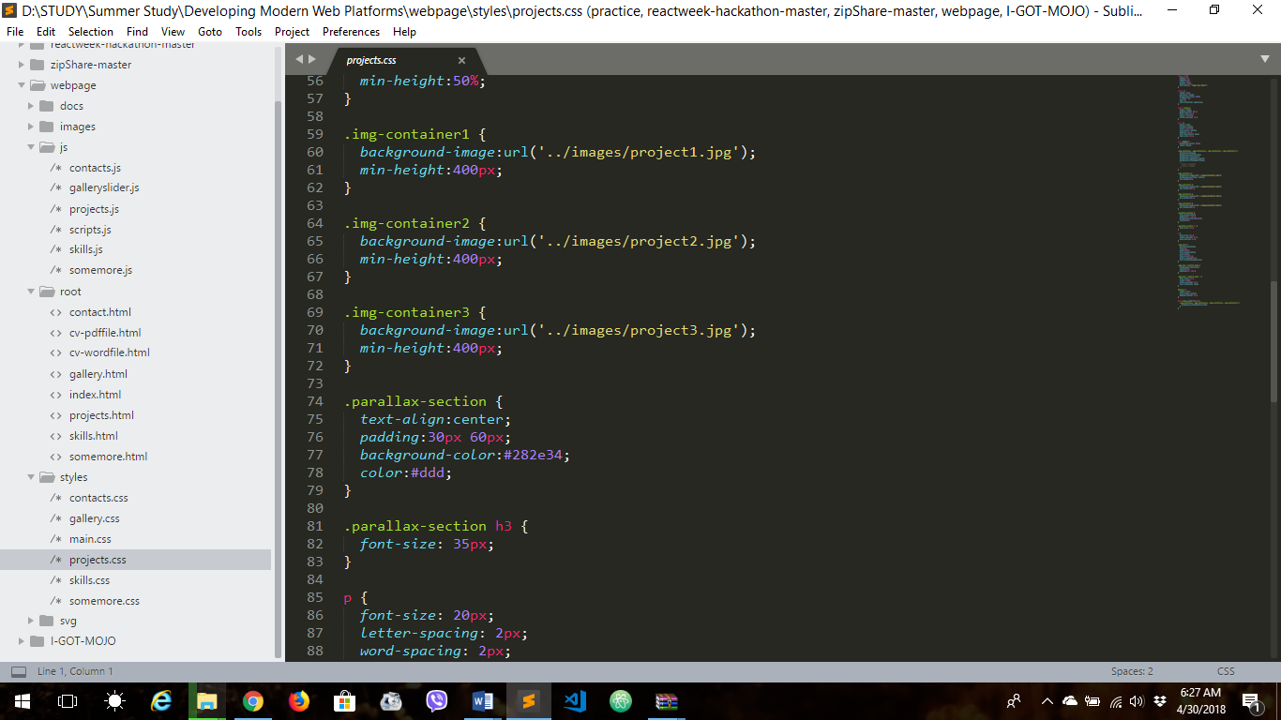

Simple alert messaging is being used for different events such as scroll, mouseover, click, etc. This function is created using external JavaScript file named as projects.js.

After projects page, there comes the gallery page. This page contains some images of me with different events which is presented as an image slider. Screenshot of the page is below.

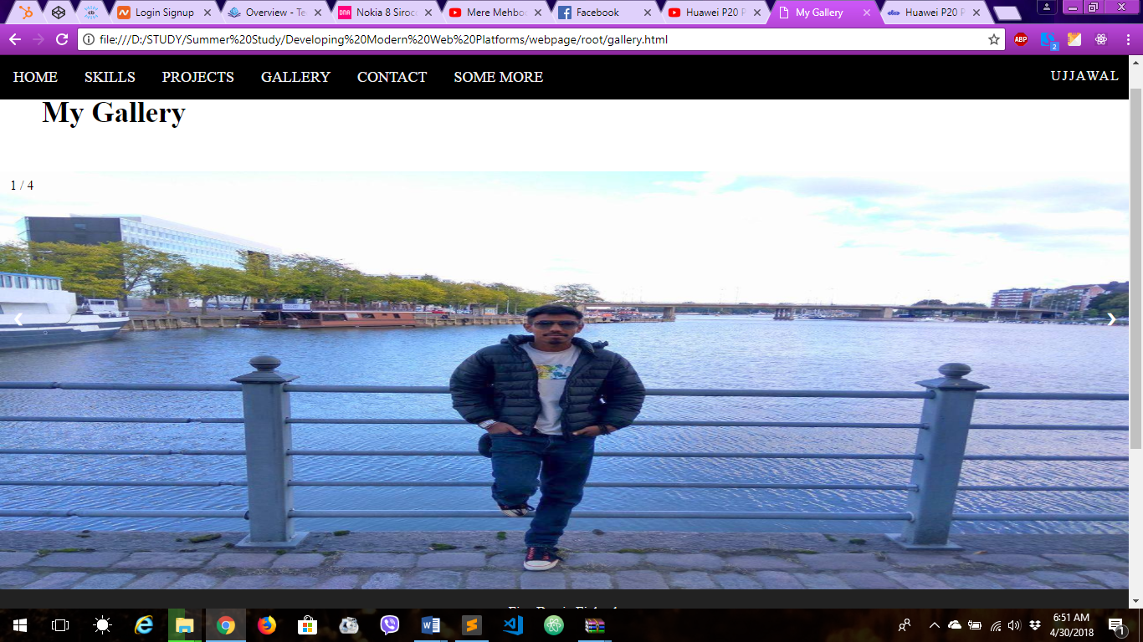

External CSS file named as gallery.css is used for styling. Screenshot is below.

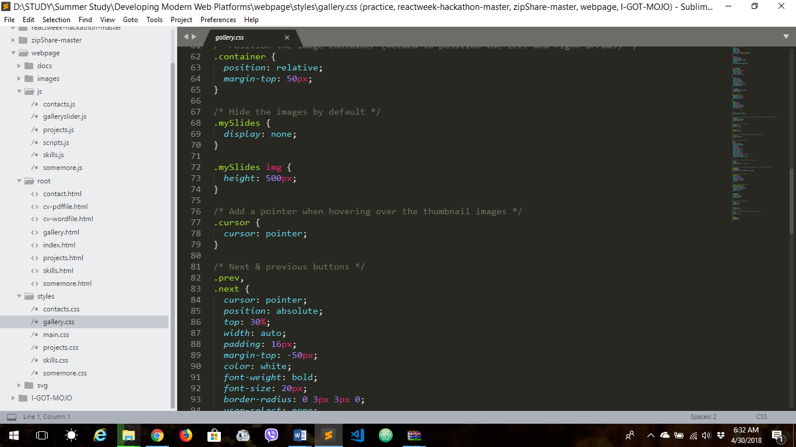

Both CSS and JavaScript was used for slider to work, a JS file is saved as galleryslider.js. It contains script for each image, its arrow for next and previous and for synchronizing thumbnails with main image.

Now comes the contact page, which contains some information to contact me like my Facebook, Instagram, twitter and gmail id. SVG images were used for social network linking. This page also contains a contact form which also can be used to contact me directly. All the typed information will be shown below once you hit the submit button. Below is the screenshot.

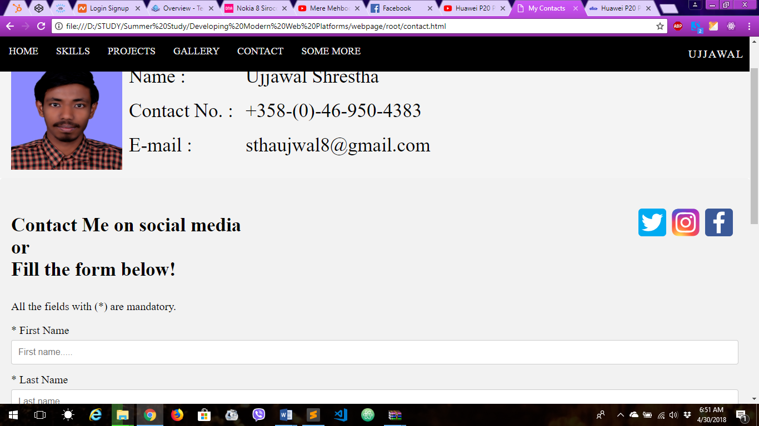

External CSS file named contacts.css was used for styling of the form and input fields. Below is the screenshot of the page.

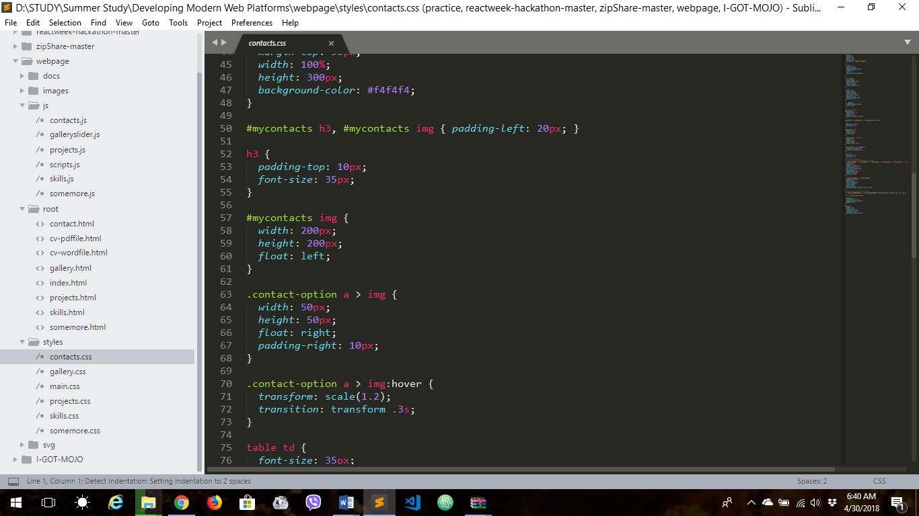

External JS file named contacts.js is linked for scripting. Script is used to show the typed result in below p tag after submit is done.

Last but not least, the somemore page. This page is extra page which is supposed to surprise my tutor. This page is a palindrome checker. Palindrome means those words which is same no matter if it starts from front or back, words like madam, noon, civic. Below is the screenshot.

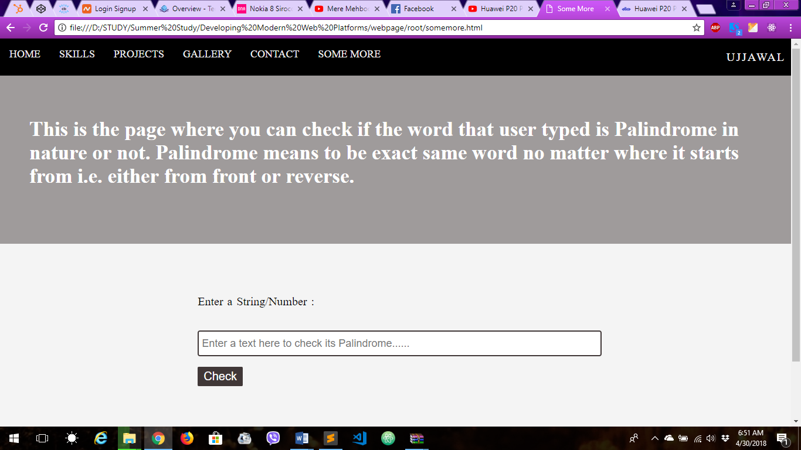

External CSS file named somemore.css is used for styling input field and submit button. Below is the screenshot.

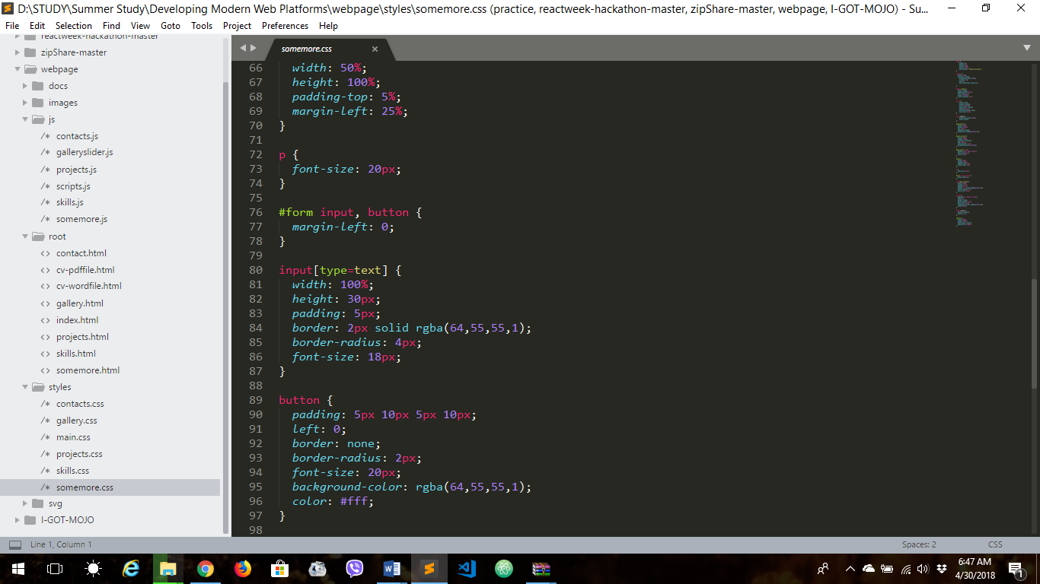

To check the palindrome nature of the words, pure JavaScript is used. The script file is saved under somemore.js file name.

**How it went?**

Well, the course was quite productive for me. The course materials, tutorials were quite good. Though, I had little knowledge about HTML and CSS, I learned a lot of new stuffs. It was quite an achievement for me that I learned DNS and IPs as well. I learned JavaScript a lot. The assignment part was a bit challenging for me, I had to go through lots of documentation apart from the material provided. Overall, I am glad I took this course as my summer study.